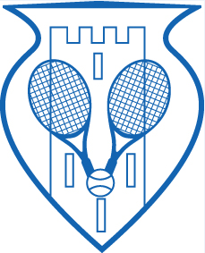

Swords Lawn Tennis Club

Club Championships 2022 - Entry Form

Our Annual Club Championships Will Take Place From
8 August – 24 September 2022

- Please tick the event(s) you wish to enter.
- Maximum number of events a competitor can enter is 3.
- The cost of entry is €7 per event. If you enter 3 events, the cost is €20.
- All entries must be submitted on the Club Championships 2022 Entry Form.
- Completed entry forms must be left in the clubhouse on/before Thursday 4 August 2022.
- Please give your entry fee to a Committee member.

Finals Day Will Be Held On Saturday, 24 September 2022
(All Finalists Must Be Available To Play On Finals Day)

Name:

Phone Number: Email Address:

Men’s Singles

Ladies Singles

Ladies Novice Singles

Men’s Doubles Partner’s Name _____________________________________________

Ladies Doubles Partner’s Name _____________________________________________

Mixed Doubles Partner’s Name _____________________________________________

Ladies Handicap Doubles Your partner will be assigned to you for this competition

Note: If you would like to enter a doubles event but do not have a partner, one will be assigned to you.

TOTAL FEE TO BE PAID: € _______________________

